Flash Fiction!
- Read up on how we define flash fiction here: http://www.writing-world.com/fiction/flash.shtml
- Scroll down the page and go exploring…. Read a piece of flash fiction with a friend!
- Begin thinking of how to create your own flash fiction. Brainstorm!!!!
- Write, Write, Write….but keep it under 1,000 words.
- Let’s submit your work to one of the following contests:
Flash Fiction Challenge!
http://www.nycmidnight.com/Competitions/FFC/Challenge.htm

Flash Fiction Online
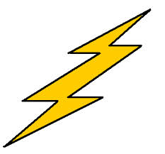
http://www.flashfictiononline.com/
The Green Tricycle
http://greentricycle.com/main/guidelines.html
SmokeLong Quarterly
http://smokelong.com/
The Vestal Review
http://www.vestalreview.net/

